UNIVERSIDADE BRASIL

UNIVERSIDADE BRASIL

GRADUATE PROGRAM
ENVIRONMENTAL SCIENCE

PROGRAM WEBSITE

TABLE OF CONTENTS
DESCRIPTION 1
Description 1
Appliance and Selection 1
2020 Classes schedule 1
Objectives 1
Áreas de atuação 2
Infrastructure 2
Faculty 3
Recommendations of CAPES/BRAZIL (Coordination for the Improvement of Higher Education Personnel) 3
Concentration Areas 4
Lines of research 4
Technical Products 4
Partnerships 4
Theses 4
Intellectual production 4
Projects in development 4
Frequently Asked Questions 4
Contact 5
General Information 5
ADMINISTRATIVE OFFICE 6
FACULTY 7
WHERE TO STUDY 8
Campus - Fernandópolis 8
Campus – Itaquera 9

DESCRIPTION
Description
The stricto sensu Graduate Program on Environmental Science (Professional Master's Program) offers interdisciplinary education to the professionals, to work at the Municipal Environmental Management, through training programs, research, development, and innovation in environmental technologies applied for public and private institutions.

Application and selection
The selection process occurs according to the specific call for application.
Apply to the Program
To get more information, please contact us by phone at 55 (17) 3465-4249

2020 Classes Schedule

Objectives
The Graduate Program on Environmental Science aims to interdisciplinary educate professionals to be able to: (a) work at the Municipal Environmental Management, (b) analyze environmental phenomena that occur in the urban and rural area, and (c) to build new references and/or technologies applied to environmental solutions (in the economic, social, and ecosystemic spheres).
To achieve this goal, the program's knowledge process dynamic and the research development adopt evolutionary direction and are strategically based on:

1- Municipal management sustainability, on the environmental, health, and educational sciences oriented towards the citys' quality development and its population, in urban and rural areas.
2 - The promotion of partnerships in which the Graduate Program on Environmental Science of Universidade Brasil proved to be able to produce innovations with patents, software, technical-scientific publications, that were made available to support and qualify managers and public and private administration technicians in the solution of social-environmental problems. Projects were developed in partnership with technicians and managers from companies and/or institutions (public and private), allowing the sharing of data, infrastructure, expertise, and funding.
3 - The pursuit of the course's improvement and continuous updating, by following market trends, and the appropriation of new studies and research that stand out in the social-environmental and health area.
4 - The demands from companies and/or public and private institutions and the general society.

The evolutionary process is accompanied by continuous evaluation of the Faculty and students from the Universidade Brasil's Graduate Program on Environmental Sciences. This process has allowed to adjust, strengthen and or implement the content of existing disciplines and/or new ones, to introduce planned activities, and to add new dimensions to its research lines.

Field of work
The fields of work are broad, involving researches on preservation and sustainable use of the biosphere natural resources and also studies related to the social environment and on health, within the following points:

- Researches focused on the development of sustainable techniques of management and natural resources use in the municipalities and their impacts on the environment;
- Researches about the influence of the environmental changes on the health and natural and artificial techniques of prevention and remediation of contamination and epidemics;
- Research on environmental, social, and economic politics focused on sustainable urban development and its impacts on society.

Infrastructure
1. Soil Analysis Laboratory (Coordinated by Professors Gisele Herbst Vazquez and Luiz Sergio Vanzela)
2. Entomology Laboratory (Coordinated by Professor Gisele Herbst Vazquez)
3. Plant pathology Laboratory (Coordinated by Professors Dora Ines Kozusny-Andreani and Roberto Andreani Junior)
4. Microbiology Laboratory (Coordinated by Professors Dora Ines Kozusny-Andreani and Danila Fernanda Rodrigues Frias)
5. Biotechnology Laboratory (Coordinated by Professors Dora Ines Kozusny-Andreani and Danila Fernanda Rodrigues Frias)
6. Seed Analysis Laboratory (Coordinated by Professors Gisele Herbst Vazquez and Roberto Andreani Junior)
7. Physics/Hydraulic Laboratory (Coordinated by Professors Luiz Sergio Vanzela and Juliana Heloisa Pinê Américo Pinheiro)
8. Remote sensing and Geoprocessing Laboratory (Coordinated by Professor Ph.D. Luiz Sergio Vanzela)
9. Plant Greenhouse (Coordinated by Professors Gisele Herbst Vazquez, Roberto Andreani Junior, and Gabriel Mauricio Peruca de Melo)
10. Teaching and Research Farm localized on Campus of Fernandópolis, with an area of 145 hectares, including an experimental area of approximately five hectares, where field experiments are conducted.

New laboratories:
11. Biodiversity and Plant Propagation Laboratory (Coordinated by Professors Gisele Herbst Vazquez and Roberto Andreani Junior)
12. Geotechlonogy and Applied Social Sciences Laboratory (Coordinated by Professors Leonice Domingos dos Santos Cintra Lima, Denise Regina da Costa Aguiar, Cristina Veloso de Castro and João Adalberto Campato Junior)
13. Solid Waste Management Laboratory (Coordinated by Professors Evandro Roberto Tagliaferro, Dora Ines Kozusny-Andreani, and Danila Fernanda Rodrigues Frias)
14. Hydrology and Climatology Laboratory (Coordinated by Professors Luiz Sergio Vanzela, Juliana Heloisa Pinê Américo Pinheiro and Cleber Fernando Menegasso Mansano)

Faculty
The Faculty is composed of Ph.D. Professors from the own institution and they are graduated in all areas of knowledge (human, exact and biological sciences), well integrating with the researches, which is very important to the course's multidisciplinarity. Besides, they have good academic, scientific and professional experience, which favors the Students’ education on the Professional Master's on Environmental Sciences. You can check the faculty list on the corresponding tab.

Recommendations of CAPES/Brazil (Coordination for the Improvement of Higher Education Personnel)
You can check information about the Program on the CAPES website:
Master's on Environmental Science

Concentration Areas
Municipal Environmental Management
Development of studies and research related to the environmental management of urban and rural ecosystems focused on the needs of municipalities and subprefectures.

Lines of research
Hereunder are presented the current lines of research of the Universidade Brasil Master's Program on Environmental Sciences

Management and Dynamic of urban and rural ecosystems
Description: Interdisciplinary execution of technical-scientific projects for studies and standardization of processes in urban and rural ecosystems, focusing on the municipal environmental management.

Health and social development on municipalities
Description: The understanding of the society and environmental integration in the urban and rural area necessarily permeates the development in social and health research. The development of studies and research, as well as technical-scientific projects, will serve as a basis for the elaboration of politics, legislation, education, and technology programs for the mitigation of inherent problems to the society and environmental interaction in the municipalities.

Technical products

Partnerships

Theses

COLCOAR AS DISSERTAÇÇOES AQUI

Intellectual production

Projects in development

Frequently Asked Questions
I have graduated, but I haven't received my diploma. What should I do?
The candidate that still doesn't have their Diploma with the proper registers, has to hand a copy of the Certificate of the Graduation Ceremony, as well as the Course Certificate of Recognition of MEC (Ministry for Education and Culture). A date for handing in the Diploma will be established at the Graduate Office.

Does the Program accept students with technologist degrees?
Yes, we do. The Graduate Program does accept technologists.

Which professionals can take a course on the program?
From all areas (human, exacts, and biological sciences), since it is an interdisciplinary course.

Contact

Telephone:
55 (17) 3465-4249

E-mail:
Prorectorate for Graduate Studies – secretaria.propesp@universidadebrasil.edu.br
Coordinator – cienciasambientais@universidadebrasil.edu.br

General Information
Thesis and dissertation model Graduate Studies
Digital book Graduate Studies model
Theses
Form of choice – elective disciplines
Course Syllabus
Reference Letter Model
Norms - Research Projects
Norms - Qualification and Thesis
Technical and Scientific Production
Funding Program to the degree of professors of Universidade Brasil PRO - Master
Projects
Bylaw - Environmental Science
ADMINISTRATIVE OFFICE

FACULTY

Acacio Aparecido Navarrete, Prof. Dr. | 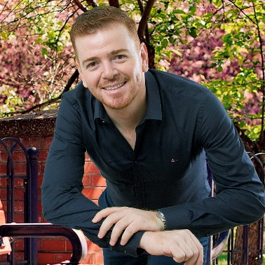
E-mail: acacionavarrete@gmail.com
Campus de Fernandópolis
» Endereço CV: http://lattes.cnpq.br/2264331242602494

Academic and professional qualifications

Bachelor of Science in Ecology at Universidade Estadual Paulista - UNESP (2007), Master in Applied Ecology at Universidade de São Paulo - USP (2009), PhD in Science (Biology in Agriculture and Environment) at USP (2013), with sandwich period at Netherlands Institute of Ecology (NIOO), The Netherlands (2010-2011), and postdoc in Brazil (Center for Nuclear Energy in Agriculture - CENA/USP) and United States (Computation Science Research Center - San Diego State University, and Institute for Environmental Genomics – The University of Oklahoma) (2013-2017). Dr. Navarrete works on Ecosystem Ecology focused on Environmental Monitoring. In this area he has developed researches with emphasis on: 1) Soil Biodiversity and Quality; 2) Agricultural and Environmental Sustainability; and 3) Ecological Risk Assessment in natural and man-made Ecosystems, and 4) Climate Change Mitigation and Adaptation.

Development projects

1. SOIL ECOGENOMICS APPLIED TO AGRO-ENVIRONMENTAL SUSTAINABILITY: AN ANALYSIS BASED ON SUGARCANE PRODUCTION SYSTEMS

Cleber Fernando Menegasso Mansano, Prof. Dr. | 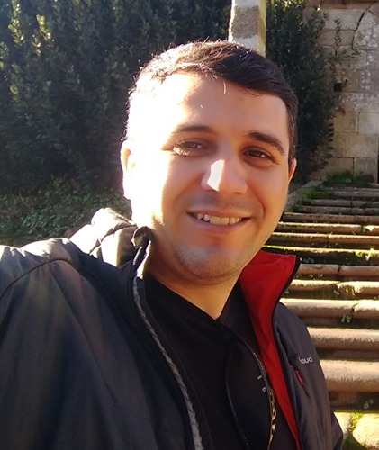
E-mail: cleber.mansano@universidadebrasil.edu.br
Campus de Fernandópolis
» Endereço CV: http://lattes.cnpq.br/7516566874692253
Academic and professional qualifications

I have done graduation in Veterinary Medicine at the Universidade Camilo Castelo Branco (2009), Master in Aquaculture at the Universidade Estadual Paulista, UNESP (2012), and Ph.D. in Aquaculture at the Universidade Estadual Paulista, UNESP (2015). I have completed my first postdoctoral fellowship at the Graduate Program in Animal Science and Technology, Universidade Estadual Paulista, UNESP (2016) and second postdoctoral fellowship at the Aquaculture Center of Universidade Estadual Paulista, UNESP. Currently, I am an Assistant Professor at the Universidade Brasil, responsible for the disciplines of Aquaculture, Animal Nutrition, Swine Culture and Production of Monogastric Animals. I am also a permanent professor in the Stricto Sensu Postgraduate Program of Environmental Sciences at the Universidade Brasil. I professor the subjects of "Environmental Education and Sustainability in the Urban Environment" and "Master Plans of Municipalities and Environment". Experience of teaching and research in Animal Production and Environment.

Projetos em desenvolvimento
Development projects
Proyectos en desarrollo
1. THE MUNICIPALITY'S RESPONSIBILITY FOR THE OMISSION IN THE INVASION, OCCUPATION AND POSSESSION IN WATERSHED AREAS
2. EVALUATION OF THE ENVIRONMENTAL IMPACTS CAUSED BY THE CONSTRUCTION OF THE BR 242-TO HIGHWAY
3. DETERMINATION AND IDEAL RELATIONSHIP OF ESSENTIAL AMINO ACIDS IN THE DIET FOR PACUS AND TILAPIA
4. DIAGNOSIS OF WATER QUALITY IN THE TURVO GRANDE HYDROGRAPHIC BASIN
5. CLINICAL EFFECTIVENESS STUDIES OF TM-700 (OXITETRACYCLINE) ON TILAPIAS (Streptococcus agalactiae and Aeromonas sp) AND SHRIMP (Vibrio spp)

Danila Fernanda Rodrigues Frias, Profa. Dra. | 
E-mail: danila.frias@universidadebrasil.edu.br
Campus de Fernandópolis
» Endereço CV: http://lattes.cnpq.br/1988644229974771
Academic and professional qualifications

Graduated in Veterinary Medicine from Universidade Brasil, and Master and Doctorate in Veterinary Medicine from Universidade Estadual Paulista Júlio de Mesquita Filho - UNESP / Jaboticabal, and also Post-doctorate in Animal Health. Nowadays she is Professor and Researcher at Universidade Brasil, Campus Fernandópolis, São Paulo, working in the Stricto Sensu Graduate Program in Environmental Sciences and several undergraduate courses on health. She is head of the One Health Research Group at CNPq, and coordinator of extension projects VetInforma, SanEduca, and QualiEnsina, from Universidade Brasil. She is a Research Ethics Committee (CEP) member with human beings, Commission of Institutional Program for Scientific and Technological Initiation, Commission of Academic Works, Dissertations and Theses of Universidade Brasil, and the Journal’s Committee of Universidade Brasil. She has expertise in Veterinary Medicine and Environmental Sciences, with an emphasis on One Health, Preventive Veterinary Medicine, Public Health, Microbiology, Food and Water Quality, Environmental Sanitation, and Waste Management.

Development projects

1. EPIDEMIOLOGY AND PLANNING: USE OF HEALTH INFORMATION FOR PUBLIC SERVICE MANAGEMENT
2. EPIDEMIOLOGICAL STUDY OF DISEASES WITH ZOONOTIC POTENTIAL
3. ENVIRONMENTAL SANITATION AND ITS IMPACT ON PUBLIC HEALTH
4.USE OF ALTERNATIVE THERAPIES TO CONTROL OF PATHOGENIC MICROORGANISMS
5. EVALUATION OF PHOTODYNAMIC THERAPY AND PHOTOBIOMODULATION IN THE CONTROL OF PATHOGENIC MICROORGANISMS AND TISSUE REGENERATION

Denise Regina da Costa Aguiar, Profa. Dra. | 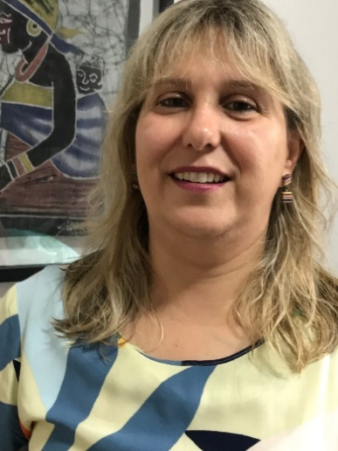
E-mail: denise.aguiar@universidadebrasil.edu.br
Campus de Fernandópolis
» Endereço CV: http://lattes.cnpq.br/1988644229974771
Academic and professional qualifications

Teaching Degree in Physical Education from the Faculty of Physical Education of Santo André (1990), Teaching Degree in Pedagogy and Master’s in Education from the Methodist University of São Paulo (2005), PhD in Education from the Pontifical Catholic University of São Paulo – PUC-SP (2011). Professor at the Graduate Program in Environmental Sciences (Professional Master's) and at the Pedagogy undergraduate course at Universidade Brasil. Member of the Commission of the Institutional Program for Scientific and Technological Initiation and the Journal Committee at Universidade Brasil. Member of the Brazilian Curriculum Association (Associação Brasileira de Currículo – ABdC) and participates in the Curriculum Research Group and Environmental Education Research Group of the National Association of Postgraduate Studies and Research in Education (Associação Nacional de Pós-Graduação e Pesquisa em Educação – ANPEd). Experience in the area of Education, researching the following themes: teacher training, democratic management, curriculum, learning and evaluation. In the area of Environmental Sciences, she researches public policy concepts, curricular practices, environmental education and management, sustainability, environmental education and public health in States and Municipalities.

Projetos em desenvolvimento
Development projects
Proyectos en desarrollo
1. CURRICULAR PRACTICES IN ENVIRONMENTAL EDUCATION IN THE MUNICIPAL EDUCATION SYSTEM OF SÃO PAULO
2. ENVIRONMENTAL EDUCATION AND SUSTAINABILITY: ANALYSIS OF POLICIES AND PRACTICES IN MUNICIPALITIES
3. ENVIRONMENTAL EDUCATION AND ITS RELATION WITH PUBLIC HEALTH
4. HEALTH EDUCATION AND SOCIAL SUSTAINABILITY IN RELATION TO THE PROBLEM OF SOLID WASTE IN MUNICIPALITIES
5. ECOPEDAGOGY AND CONTINUING EDUCATION OF EDUCATORS

Dora Inés Kozusny-Andreani, Profa. Dra. | 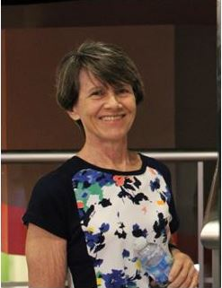
E-mail: dora.andreani@universidadebrasil.edu.br
Campus de Fernandópolis
» Endereço CV: http://lattes.cnpq.br/1260217332585007
Academic and professional qualifications

Graduated in Genetics by the National University of Misiones (1981), Magister in Agronomy (Genetics and plant breeding) by the State University of São Paulo Júlio de Mesquita Filho (1992) and Doctor in Agronomy (Vegetable Production) by the State University of São Paulo Júlio de Mesquita Filho (1997). Full Professor of the Stricto Sensu Program Professional Master's Degree in Environmental Sciences and of the Academic Master's and Doctorate in Biomedical Engineering and the graduation courses in Medicine and Veterinary Medicine. Head of the Microbiology laboratory at the Brazil University. Professor of the Stricto Sensu Graduate Program Professional Master in Environmental Sciences and the Master and Doctorate in Biomedical Engineering and the graduation courses in Medicine and Medicine Veterinary. Head of the Microbiology laboratory at the Brazil University. Member of the Commission for academic papers, dissertations and theses of the Brazil University. She has experience in the area of Microbiology, working on the following topics: Food Microbiology. Agricultural and environmental microbiology. Disease-causing microorganisms. Use of medicinal plants and ozone to control microorganisms.

Development projects

1. USE OF OZONE AND MEDICINAL PLANTS TO CONTROL MICROORGANISMS
2. ASSESSMENT OF ENVIRONMENTAL CONTAMINATION BY POTENTIALLY PATHOGENIC MICROORGANISMS
3. BIOAEROSOL DIVERSITY PRESENT IN RURAL, URBANIZED AND HOSPITAL ENVIRONMENTS
4. INCIDENCE OF THE MAIN INFECTIOUS DISEASES IN THE CITY OF FERNANDÓPOLIS - SP
5. MICROBIOLOGICAL QUALITY OF FOOD

Evandro Roberto Tagliaferro, Prof. Dr. | 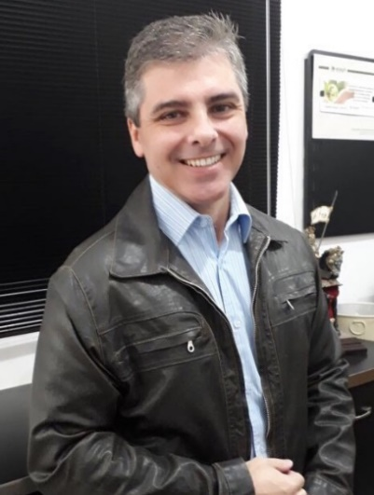
E-mail: evandro.tagliaferro@universidadebrasil.edu.br
Campus de Fernandópolis
Endereço CV: http://lattes.cnpq.br/0496505256897860
Academic and professional qualifications

Graduated in Civil Engineering from the Sao Jose do Rio Preto Engineering College / SP - Brazil, specialization in Environmental and Sanitary Engineering from Candido Mendes College / RJ - Brazil, investigative sufficiency in Business Administration and International Trade from Facultad de Ciencias Económicas y Empresariales / Badajoz - Spain and doctorate in Business Administration and International Trade (Environment, Economy, Human Development and Sustainability emphasis) from the University of Extremadura - Spain. Worked as a Professor in Environmental Sciences in the Civil Engineering Undergraduate Course at Dom Pedro II Integrated Faculties and in Environmental Impact Assessment, Soil Management and Environmental Auditing in the Post-Graduate Program in Environmental Management (EcoGgestion) at UNIP – University of Sao Paulo. He was the professor responsible for the subjects of Licensing and Environmental Impact Assessment in the Post-Graduate Program in Environmental Management at SENAC and Environmental Management in the Post-Graduate Program in Integrated Management of Quality, Environment, Safety and Health at Work and Social Responsibility. Methodological Organizer and Coordinator of the Work Plan Proposal and Roadmap for Economic-Financial Projects for the Environmental Commodities Market, he was also a Scientific Methodological Adviser and Co-Organizer of the Study Centers and Coordinator of the Strategic and Marketing Management Studies Center of Solid Waste – Sector of Financials’ Development and Strategies Studies - of the BECE Project (Brazilian Environmental Commodities Exchange). Author of the book Systemic Changes and Market Transmutations - The BECE Project (Brazilian Stock Exchange for Environmental Commodities): a proposal to achieve sustainable development. He is a member of ISWA (International Solid Waste Association) and ABLP (Brazilian Association of Solid Waste and Public Cleaning), where he served on the board (2008-2010) and was an editorial council member of the Public Cleaning magazine. He is currently a full Professor and Researcher in the Graduate Program in Environmental Sciences at Brazil University, responsible for the subjects of Environmental Impact Assessment, Public Policies, Municipal Economics and Environment, Alternatives for Urban Environmental Sanitation and Environmental Technologies Applied to Counties Environmental Management. In the Graduation, he integrates the teaching teams of Agronomy, Veterinary Medicine, Architecture and Urbanism, and, Administration. He is the Coordinator of the Research Line in Urban and Rural Ecosystems’ Management and Dynamics. Coordinator of the Exact, Agrarian and Environmental Sciences area of the University of Brazil Journal Committee. Member of Technical-Scientific Commissions of national and international events and journals. Invited Professor of the Post-Graduate Program (Master's) in Ecological Production System Agroprocessing at the Zambezi University, responsible for the subject of Agrarian Management (Program that integrates the Brazil-Mozambique Cooperation Project in the strengthening of graduate studies, with FAO’s support and organization). He has almost 30 years of experience with the private sector, half of them acting as director, in the areas of Engineering, Administration, Economics, Environment and Waste, acting mainly in Environmental Management, Environmental Licensing, Management and Waste Management, Urban Cleaning, Environmental Education, Business Management, Socioeconomic Management, among others. In 2021, he received the title of ISWA International Waste Manager - Professional International Certification Status, granted by the International Waste Manager (IWM) Professional Certification Program of ISWA (International Solid Waste Association), based in Rotterdam, in the Netherlands.

Development projects

1. ENERGY RECOVERY OF WASTE: BLENDING IN THE NORTHWEST OF SAO PAULO
2. ENVIRONMENTAL MANAGEMENT IN COUNTIES
3. ANALYSIS OF THE BENEFITS OF MUNICIPAL ENVIRONMENTAL LICENSING IN LIMEIRA DO OESTE / MG
4. ANALYSIS OF ENVIRONMENTAL SUSTAINABILITY CRITERIA METHODOLOGY IN FEDERAL PUBLIC BIDDINGS
5. STUDY ON THE MANAGEMENT AND HOUSEHOLD SOLID WASTE MANAGEMENT IN SUZANO / SP

Gisele Herbst Vazquez, Profa. Dra. | 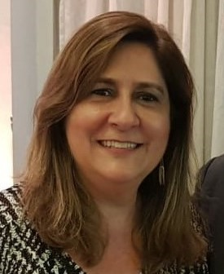
E-mail: gisele.vazquez@universidadebrasil.edu.br
Campus de Fernandópolis
» Endereço CV: http://lattes.cnpq.br/3050276760782685
Academic and professional qualifications

Agronomist by Universidade de São Paulo (USP / ESALQ) (1986). Master of Agronomy (Phytotechnics) by Universidade de São Paulo (USP / ESALQ) (1995) and PhD of Agronomy (Production and Seed Technology) by Universidade Estadual Paulista (UNESP) (2005). Specialist of Didactics of Higher Education at Centro Universitário do Norte Paulista (UNORP) (1997). Worked as a professor at UNESP / Ilha Solteira and UNESP / Jaboticabal, and has been a full professor of the Interdisciplinary Master in Environmental Sciences since 2012 and of the Undergraduate Course in Agronomy since 1998 both at Universidade Brasil. Responsible for the Seed Analysis Laboratory and for the coordination of Universidade Brasil’s Central Laboratory. In 2007, joined the INEP-BASis Bank of Assessors. Worked as a full member of CREA / SP from 2012 to 2017, returning to a new term in 2021. Awarded in 2018 the Diploma of Merit for the relevant services provided to Agronomy offered by CREA / SP. Supervised 30 Master's students, 6 Specialization students, 134 Course Conclusion Papers and 32 students for Scientific Initiation. Organizer of 2 books, author of 10 book chapters, 55 scientific articles and 95 technical papers. Experienced in the field of Agronomy, with an emphasis on Phytotechnics, working mainly on the following themes: Landscaping, Urban Forestry, Biodiversity and Environment; Seed Production and Technology; Management of Annual Crops and Sugarcane.

Projetos em desenvolvimento
Development projects
Proyectos en desarrollo
1. URBAN VEGETATION COVER AND THE ENVIRONMENTAL AND LIFE QUALITY OF MUNICIPALITIES
2. MUNICIPAL SQUARES: HISTORICAL-CULTURAL, LANDSCAPE AND ARCHITECTURAL ASPECTS
3. ENVIRONMENTAL TAX INCENTIVES
4. POSSIBILITIES FOR SUSTAINABLE MANAGEMENT OF LEGAL RESERVE
5. QUALITY OF HOMEMADE BEERS SOLD IN OPEN MARKETS IN THE CITY OF GUARAPUAVA / PR

João Adalberto Campato Júnior., Prof. Dr. | 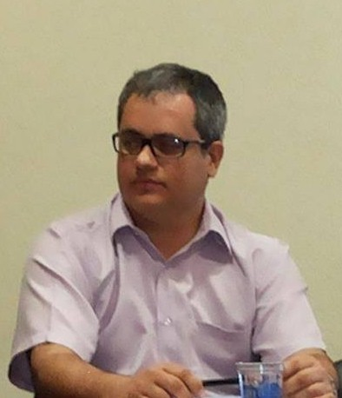
E-mail: joao.campato@universidadebrasil.edu.br
Campus de Fernandópolis
» Endereço CV: http://lattes.cnpq.br/8881219894595704
Academic and professional qualifications

He has a Bachelor’s Degree in Language and Literature - Qualification in Translation from the São Paulo State University "Júlio de Mesquita Filho" (UNESP) (1992). Specialist in the area of Integrated School Management and Pedagogical Practices from the Cândido Mendes University. He has a Master Degree in Brazilian Literature from the São Paulo State University (UNESP) (1997) and a Ph.D. Degree in Portuguese Language Literatures – UNESP (2002). He has post-doctoral degree in Comparative Studies of Portuguese Language Literatures from the University of São Paulo (USP). He has a post-doctoral degree in Literary Theory from the Campinas State University (UNICAMP). He has a post-doctoral degree in African Literatures of Portuguese Language from the Rio de Janeiro State University (UERJ). He has a post-doctoral degree from the Federal University of Mato Grosso do Sul (UFMS). He is the author of several books and scientific articles. He was a Collaborating Professor in the Department of Vernacular and Classical Letters at the State University of Londrina (UEL). He is a permanent professor of the Interdisciplinary Master in Environmental Sciences at Universidade Brasil. Teaching and research experience in Environmental Communication, Ecocritics (representation of the environment by literary/artistic discourse), Ecological Discourse Analysis, Rhetorical Study of Environmental Polemics, Environmental Education, Environmental Journalism.

Development projects

1. THE GOLF COURSE CONTROVERSY AND THE RIO JANEIRO OLYMPICS: AN ENVIRONMENTAL COMMUNICATION STUDY
2. ENVIRONMENTAL COMMUNICATION AND ECOTOURISM: ELABORATION OF AN ECOTOURISM GUIDE FOR THE MUNICIPALITY OF ILHA SOLTEIRA
3. SUSTAINABLE LIBRARY MANAGEMENT: THE CASE OF UNIVERSIDADE BRASIL
4. PROPOSAL FOR TEACHING AND LEARNING CRITICAL ENVIRONMENTAL EDUCATION THROUGH POEMS
5. SOCIAL REPRESENTATIONS: ENVIRONMENT, ENVIRONMENTAL EDUCATION AND GEOGRAPHY

João Alexandre Saviolo Osti, Prof. Dr. | 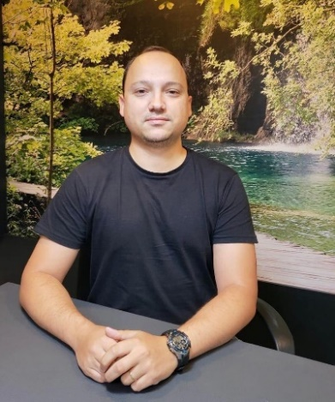
E-mail: jale.osti@gmail.com
Campus de Fernandópolis
» Endereço CV: http://lattes.cnpq.br/5205232657580262

Academic and professional qualifications

Biologist by Centro Universitário Fundação Santo André (degree in 2006) and (bachelor in 2007). Master in Aquaculture and Fisheries by Instituto de Pesca (2009), PhD in Aquaculture by Aquaculture Center from UNESP (2013), Post-doctorate in Ecology by the Biosciences Institute from UNESP, Rio Claro (2016) and Post-doctorate by Postgraduate and Research Center, Master in Geoenvironmental Analysis at UNG University (2020). Currently a professor at UNG University where he is accredited in the Postgraduate Program in Geoenvironmental Analysis (MAG) and collaborates in the Postgraduate Program in Environmental Sciences at Universidade Brasil. Has experience in the area of aquatic ecosystem ecology, working mainly on the following themes: algae and cyanobacteria ecology, environmentally sustainable management in aquaculture, ecology and dynamics of fishponds and in the assessment and treatment of aquaculture effluents.

Projetos em desenvolvimento
Development projects
Proyectos en desarrollo
1. ECONOMIC EVALUATION OF THE APPLICATION OF ARTIFICIAL FLOATING ISLANDS SYSTEMS AIMING AT THE ENVIRONMENTAL SUITABILITY OF AQUACULTURE EFFLUENTS

Juliana Heloisa Pinê Américo Pinheiro, Profª. Drª. | 
E-mail: juliana.pinheiro@universidadebrasil.edu.br
Campus de Fernandópolis
» Endereço CV: http://lattes.cnpq.br/7218792841038996
Academic and professional qualifications

Graduated in Biological Sciences from the Faculty of Engineering at UNESP in Ilha Solteira - SP (2007). Master in Civil Engineering in the Area of Water Resources and Environmental Technologies by the Faculty of Engineering of UNESP in Ilha Solteira - SP (2010). Specialist in Environmental Management from the School of Agriculture "Luiz de Queiroz" - ESALQ / USP of Piracicaba - SP (2012). PhD in Aquatic Biology at the Aquaculture Center at UNESP in Jaboticabal - SP (2015). Post-doctorate by the Faculty of Engineering of UNESP in Ilha Solteira - SP (2017). Full Professor accredited in the Professional Master's Degree in Environmental Sciences at the Brazil University (UB) responsible for the orientation of students and for the subjects of "Climatology and Urban Hydrology" and "Advanced Topics in Integrated Management of Municipalities". Takes classes and guides undergraduate students in UB graduate courses in Agronomy, Veterinary Medicine, Biomedicine and Pharmacy. Coordinator of the Academic Works Standards Commission, Member of the Collegiate and Structural Development Nucleus (SDN) of the Veterinary Medicine Course at UB. Accredited professor in the Academic Master's Degree in Civil Engineering - Water Resources and Environmental Technologies at the School of Engineering at UNESP in Ilha Solteira - SP. Member of the Studies and Technical Standards Committee of the Brazilian Association of Technical Standards ABNT / CB-014 / CE 014000003 “Identification and description”. Member of the Commission for Studies and Technical Standards ABNT / CEE-106 “Ecotoxicological Analysis”. Leader of the CNPQ research group “Water Resources, Ecotoxicology and Environmental Technologies”. She is the author of scientific articles in national and international journals with a high impact factor and Qualis of relevance in the Interdisciplinary and Environmental Sciences area. She acts as an expert in national and international journals. Author of books and chapters in the area of Water Resources Management, Watersheds and Sanitation. Researcher in the areas of Water Resources and Sanitation, Water Quality and Management, Technologies and Environmental Management, and Ecotoxicology. Develops research projects in partnership with international teaching and / or research institutions from Iran (Ardabil University of Medical Sciences), Mexico (School of Engineering and Sciences, Campus Monterrey), Colombia (University of Nariño), Austria (Medizinische Universität Innsbruck) and China (Huaiyin Institute of Technology).

Development projects

1. WATER RESOURCES, ECOTOXICOLOGY AND ENVIRONMENTAL TECHNOLOGIES
2. SEASONAL DYNAMICS OF MICROBIAL CONTAMINATION OF SURFACE WATERS AND RESISTANCE OF ISOLATES TO ANTIBIOTICS
3. ECOTOXICITY OF PESTICIDES FOR AQUATIC ORGANISMS OF DIFFERENT TROPHIC LEVELS
4. DISPOSAL OF MEDICINES AND THE POPULATION'S ENVIRONMENTAL PERCEPTION OF THEIR DAMAGE TO THE ENVIRONMENT
5. ANALYSIS OF BRAZILIAN LEGISLATION ON THE PARAMETERS FOR PESTICIDES IN WATER FOR HUMAN CONSUMPTION

Leonice Domingos dos Santos Cintra Lima, Profa. Dra. | 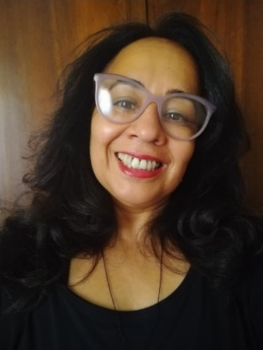
E-mail: leonice.lima@universidadebrasil.edu.br
Campus de Fernandópolis
» Endereço CV: http://lattes.cnpq.br/0391005456034509
Academic and professional qualifications

Graduated in Social Work from UNESP / 1983, Specialist in Social Work Methodologies / 1995, Specialist in Hospital Administration / 1995, Master in Social Work from UNESP / 2003 and PhD in Social Work from UNESP / 2009. This professor work in Graduate Program in Environmental Sciences at Brasil Universidade: Professor in the subjects of Public Policy, Municipal Economy and Environment; Culture, Society, Heritage and Environment in Municipalities. Graduation – Brasil Universidade: Pedagogy and Physical Education Course - Disciplines: Social Relations, Gender and Human Rights; Philosophy of Education, Medical Course: Module / Sub-module Surveillance and Health Information Systems: Black and Indigenous Population Health; FUNDEC-UNIFADRA: Medical Course - Discipline: Social Analysis and Ethnic-Racial Relations. Research Ethics Committee - HEC Brasil Universidade Brasil. Researcher in the areas: Socio-environmental Policies, Environmental Education, Gender Inequality, Racial and Minority Rights. Research Groups NCSTD (National Council for Scientific and Technological Development): 1) Environmental Sciences and Health-UNIVBRASIL; 2) Unique Health in Focus-UNIVBRASIL; 3) Transversal Education – UFES.

Projetos em desenvolvimento
Development projects
Proyectos en desarrollo
1. PUBLIC POLICIES AS A STRATEGY TO PROTECT THE INTELLECTUAL AND CULTURAL PROPERTY OF INDIGENOUS COMMUNITIES: A WAY FOR COMBATING BIOPIRACY
2. THE ANALYSIS OF THE WATER QUALITY FOR URBAN SUPPLY IN THE MUNICIPALITY OF PORTO NACIONAL-TO
3. STRATEGIES IN THE FIGHT AGAINST BIOPIRACY THROUGH THE ADOPTION OF PUBLIC POLICIES IN THE PROTECTION OF THE INTELLECTUAL PROPERTY OF INDIGENOUS SOCIETIES
4. SCIENTIFIC INITIATION: “THE RACE / COLOR MATTER IN RESEARCH WITH HUMANS: RACIAL INEQUALITY AS A SOCIAL ISSUE”

Luiz Sergio Vanzela, Prof. Dr. | 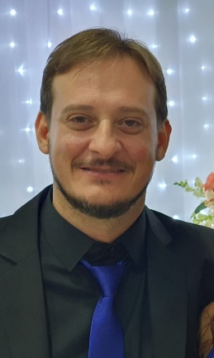
E-mail: luiz.vanzela@universidadebrasil.edu.br
Campus de Fernandópolis
» Endereço CV: http://lattes.cnpq.br/0284046584743018
Academic and professional qualifications

Agronomist from São Paulo State University (Unesp) / Ilha Solteira Campus (2001), Master in Agronomy from UNESP / Ilha Solteira (2004) and PhD in Agronomy from UNESP / Ilha Solteira (2008). Currently Coordinator and Full Professor in the Graduate Program in Environmental Sciences at Universidade Brasil (Brazil University), Professor in the Undergraduate Course in Agronomic Engineering at Universidade Brasil / Fernandópolis Campus. Member of the Technical Chamber of Groundwater and Multiple Uses of the Turvo / Grande River Basin Committee. As a Professor and Researcher, he works in the areas of Water and Soil Engineering, Integrated Water Resources Planning, Climatology, Georeferencing and Geoprocessing.

Projetos em desenvolvimento
Development projects
Proyectos en desarrollo
1. RESEARCH ON MUNICIPAL SOLID WASTE MANAGEMENT
2. ADVANCED STUDIES IN URBAN CLIMATE
3. WATER RESOURCES IN THE MUNICIPALITIES
4. USE OF GEOTECHNOLOGIES IN ENVIRONMENTAL SURVEYS
5. INFLUENCE OF SOCIO-ENVIRONMENTAL FACTORS ON DISEASE INCIDENCE

Marco Antonio de Andrade Belo, Prof. Dr. | 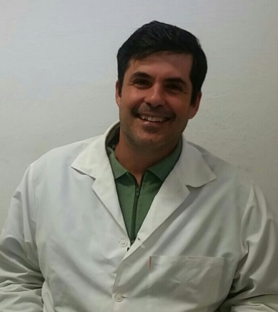
E-mail: marco.belo@universidadebrasil.edu.br
Campus de Descalvado
» Endereço CV: http://lattes.cnpq.br/5860709306530042
Academic and professional qualifications

Veterinarian graduated from FACV-UNESP (Jaboticabal) and PhD in Veterinary Medicine (Animal Pathology area).
Works with immunopharmacology and ecotoxicology, developing prospection studies for new drugs and vaccines, conducting tests of efficacy, clinical and toxicological safety, as well as pharmacokinetic studies of residues to compose pharmacological "Dossie" for registration of drugs in the MAPA (Brazilian Ministry of Agriculture, Livestock and Supply), with important experience in aquatic animal health, mainly production fish such as tilapia, pacus and tambaquis. Researcher with a scientific productivity grant from the National Council for Scientific and Technological Development -CNPq.

Projetos em desenvolvimento
Development projects
Proyectos en desarrollo
1. STRATEGIES FOR SUSTAINABILITY OF AQUACULTURAL ACTIVITY AND PRESERVATION OF WATER RESOURCES

Roberto Andreani Junior, Prof. Dr. | 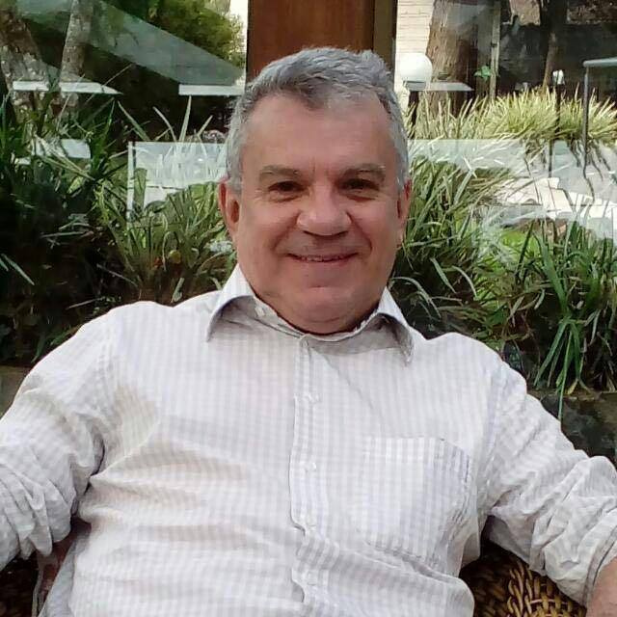
E-mail: roberto.andreani@universidadebrasil.edu.br
Campus de Fernandópolis
» Endereço CV: http://lattes.cnpq.br/5863157086821275
Academic and professional qualifications

Graduated in Agronomy from the University of Taubaté (1983), Master in Agronomy (Vegetable Production) from University Estadual Paulista Júlio de Mesquita Filho (1995) and PhD in Agronomy (Vegetable Production) from University Estadual Paulista Júlio de Mesquita Filho (1998). He is currently a full professor at University Brasil, Campus de Fernandópolis-SP. He has experience in the field of Agronomy working in the areas of Biology and Weed Management, Vegetable Production, Silviculture and Forest Management with an emphasis on the Recovery of Degraded Areas of Riparian Forest. Takes classes in Silviculture and Forest Management, Biology and Weed Control, General Vegetable and Medicinal Plants in the Agronomy course at University Brasil. He is a Professor of the Postgraduate Course in Environmental Sciences “Stricto Sensu” at the University of Brazil, where he teaches the disciplines of Vegetable Recovery of Degraded Areas and Biodiversity, Landscape and Urbanization.

Projetos em desenvolvimento
Development projects
Proyectos en desarrollo
1. EVALUATION OF THE ANTIFUNGAL EFFECT OF ESSENTIAL OILS IN THE CONTROL OF ANTHRACNOSE IN FRUITS.
2. USE OF TECHNIQUES TO OVERCOME DORMANCY IN FOREST SEEDS.
3. THE CULTIVATION OF MEDICINAL PLANTS AS A CULTURAL RESCUE OF HANDLING HERBS FOR HUMAN HEALTH AND ENVIRONMENTAL AWARENESS IN THE PRESERVATION OF SPECIES
4. USE OF COMPOST FOR THE PRODUCTION OF VEGETABLES BY STUDENTS OF PUBLIC SCHOOLS.
5. PROPAGATION AND MANAGEMENT OF PLANT SPECIES

WHERE TO STUDY

Campus - Fernandópolis
Adress: Road Projetada F-1, no number
District: Fazenda Santa Rita
City: Fernandópolis - SP
Zip Code: 15600-000

Answering service
Telephone: 55 (17) 3465-4200

Founded in 1995, the Fernandópolis campus of Universidade Brasil was the first step of the Institution in the process of expansion towards the countryside of Sao Paulo. The choice of the city was strategic since it considered the social-economic aspect and the localization at the extreme Northwest of the State, which attracts students from states as Sao Paulo, Minas Gerais and, Mato Grosso do Sul.

The campus occupies 60 bushels and offers 32 undergraduate courses, 7 graduate lato sensu courses, and 2 stricto sensu graduate programs. It includes a library, veterinary hospital, dental clinic, health laboratories, computer lab, junior company, a center of legal practices, basic health unit, and dorms for Medicine students, associated with the Santa Casa de Fernandópolis hospital.

The institution has more than 50% of Masters and Ph.Ds. It offers services to the local community of legal assistance, business consulting to small and medium entrepreneurs, services of health care, veterinary care for large and small animals, veterinary laboratory tests, as well as soil laboratory tests, and bacteriological analysis of food. Services of Special Civil Courts, conciliation in Family Law, management of cattle, swine, and sheep.

Fernandópolis is an economically agricultural, commercial, and industrial city. 44% of the economic establishments are in the commercial sector, 27% in the service sector, and 5% in the industrial sector. However, the service sector is responsible for the majority of the formal employment, 39% of the number of vacancies. Despite the importance of industry and commerce on the regional economy, agriculture is still the main source of economic buoyancy. The income that drives the commercial and service sector of the city comes from the agriculture of the city of Fernandópolis. The agricultural production of the city and region is centered in temporary cultures, with a great emphasis on sugar cane cultivation, representing about 44% of the total cultivated area. Within the permanent cultures, orange and other citrus are responsible for the majority of the worth. The beef and dairy cattle industry is also of great importance for the region, activities which reached together more than 23% of the agriculture production worth.

Campus – Itaquera

Address: Street: Carolina Fonseca, 584
District: Itaquera
City: Sao Paulo - SP
Zip Code: 08230-030

Answering service
Telephone: 55 (11) 2070-0000
WhatsApp: 55 (11) 99816-2387

The district of Itaquera, localized on the East Zone of Sao Paulo, has developed in great part under the classic form of allotment and villages. Based at the Carolina Fonseca street, originated from the Camilo Castelo Branco Colleges, and the first authorized courses in 1971 were recognized in 1974. The years that followed were dedicated to the expansion of the number of courses in such a way that, at the end of the decade of 1980, the Institution already had a total of 24 undergraduate courses.

The Itaquera Campus currently has 30 in-person undergraduate courses and its facilities include climatized rooms with fans and air conditioning, dimensioned according to the area and technical norms inherent to the place they are. The hydro-sanitary installation meets the norms, including the security demands that are needed for good working.

The Itaquera Campus is also the main office of the Universidade Brasil School, which offers Elementary School, Middle School, and High School. We aim to integrate the School activities with the academic activities to motivate the student that finishes the basic attention to continue on their formative itineraries in the education domain.

2021

